**Assignment 11.6**

1.Find the top five kinds of GoogleKnowlege_Occupation people who were guests in the show, in a particular time period i.e., between '1/11/99' and 6/11/99. You need to write an UDF to compare the dates. You can download the dataset from the below link Daily_Shows_Guest_Data

Dataset Description:

YEAR – The year the episode aired. GoogleKnowlege_Occupation -Their occupation or office, according to Google’s Knowledge Graph. On the other hand, if they are not in there, how Stewart introduced them on the program. Show – Air date of the episode. Not unique, as some shows had more than one guest Group – A larger group designation for the occupation. For instance, U.S senators, U.S presidents, and former presidents are all under “politicians” Raw_Guest_List – The person or list of people who appeared on the show, according to Wikipedia. The GoogleKnowlege_Occupation only refers to one of them in a given row.

**Pig Script**

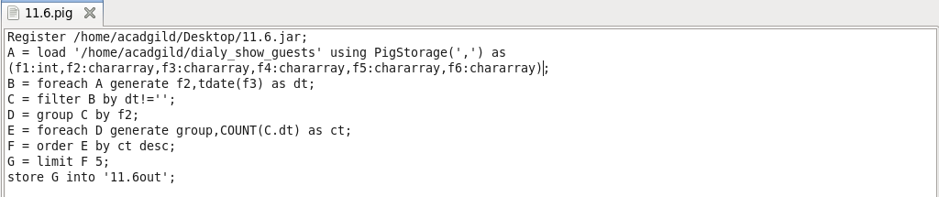

**UDF Code**

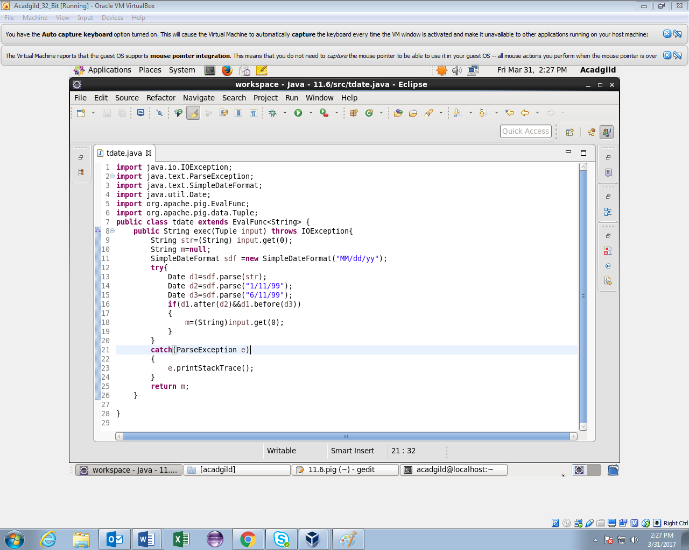

**Running Pig Script**

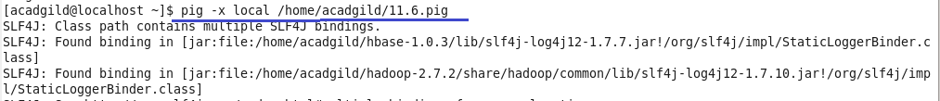

**Output**

